

**Green University of Bangladesh**

**Department of Computer Science and Engineering (CSE)**

**Faculty of Sciences and Engineering**

**Semester: (Summer, Year:2025), B.Sc. in CSE (Day)**

**LAB REPORT NO: 1**

**Course Title:** Database Lab

**Course Code:** CSE 210 **Section:** 232-D1

**Lab Experiment Name**: Implement different kinds of integrity constraints.

**Student Details**

|  |  |  |
| --- | --- | --- |
| **Name** | | **ID** |
| **1.** | ASHAB UDDIN | 232002274 |

**Submission Date : 07-07-2025**

**Course Teacher’s Name :** Farhana Akter Sunny

**[For Teachers use only: Don’t Write Anything inside this box]**

|  |
| --- |
| **Lab Report Status**  **Marks: ………………………………… Signature:.....................**  **Comments:.............................................. Date:..............................** |

1. **TITLE OF THE LAB EXPERIMENT:**

Implement different kinds of integrity constraints.

**OBJECTIVES:**

* To Define Primary Keys for uniquely identifying records.
* To Establish Composite Keys across multiple columns.
* To Apply Unique Constraints to enforce data uniqueness.
* To Enforce Not Null Constraints to prevent missing values.
* To Use Check Constraints to validate data entries.
* To Create Foreign Key Relationships between tables.
* To Preserve Referential Integrity across related data.
* To Promote Consistency and Reliability of stored information.

**PROCEDURE:**

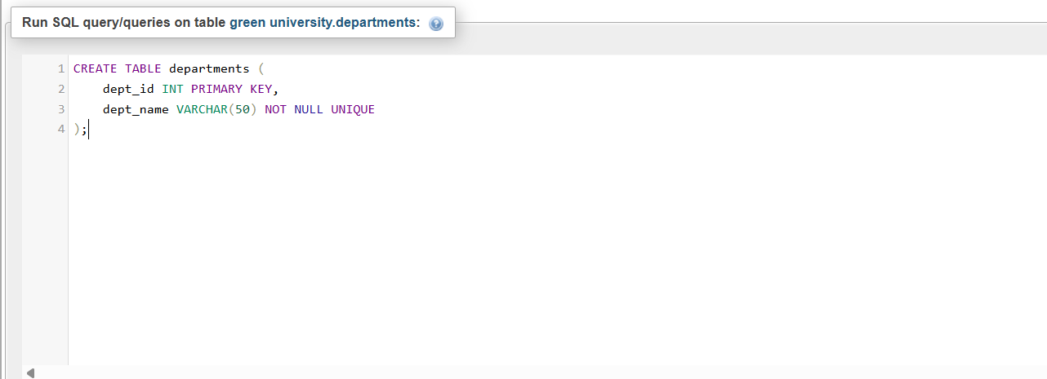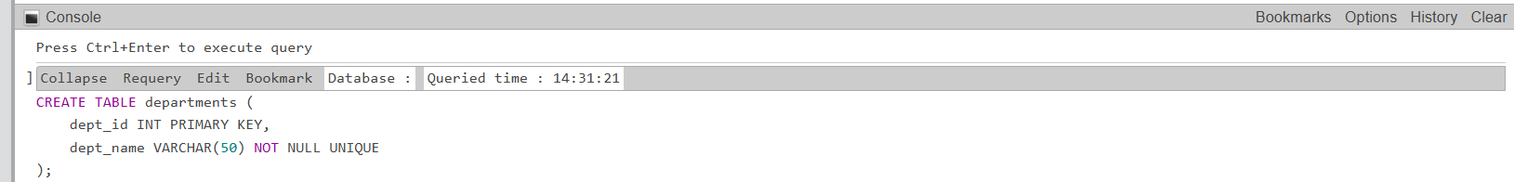

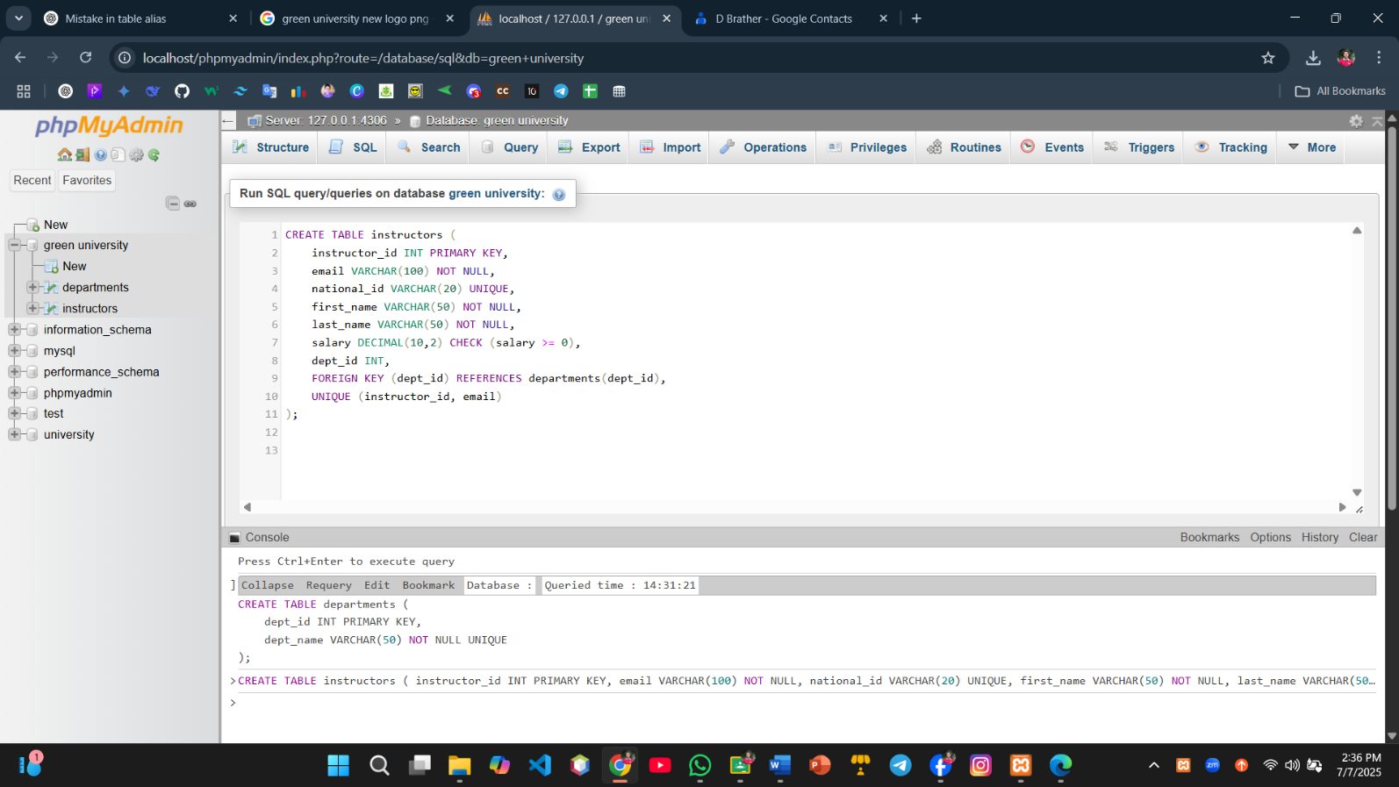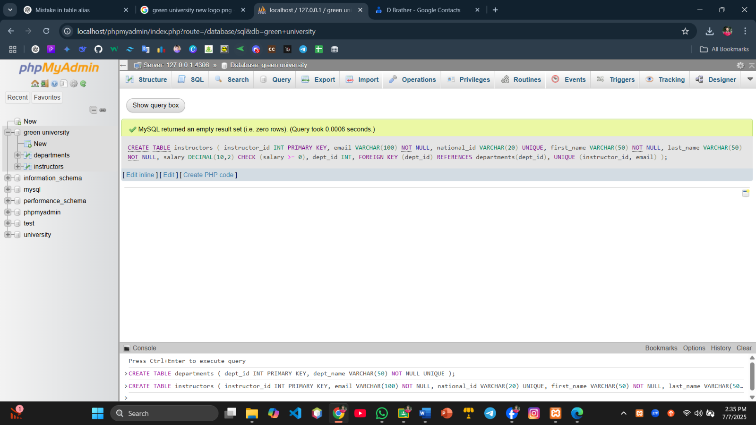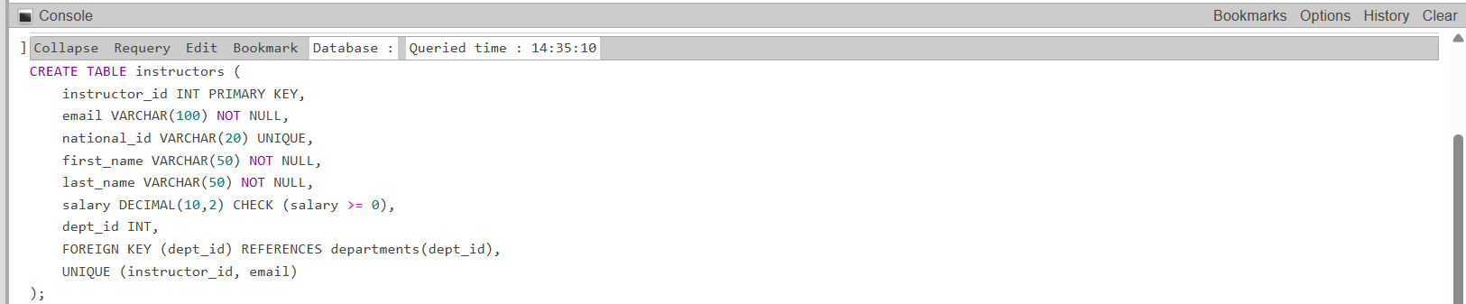

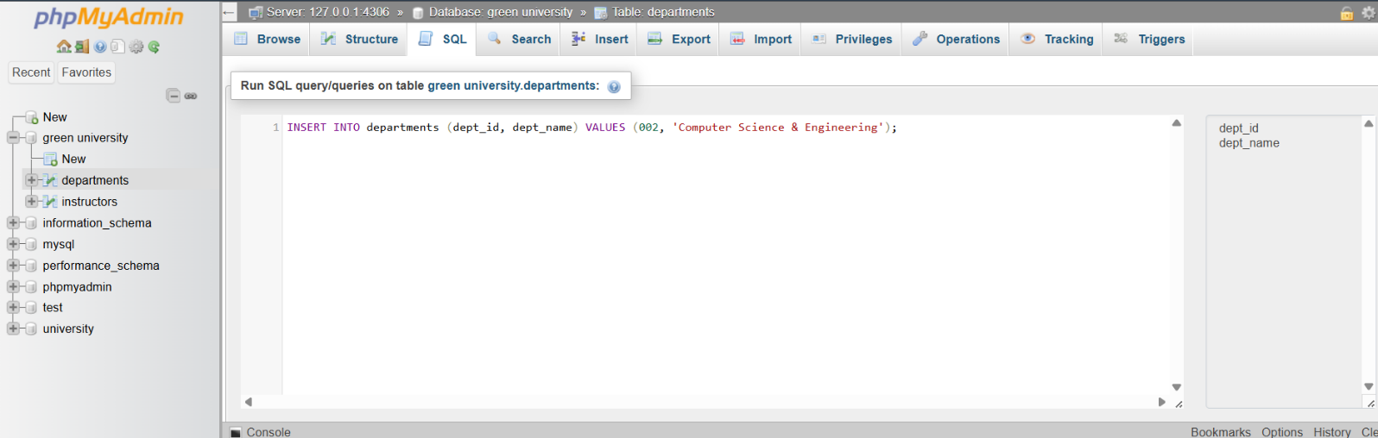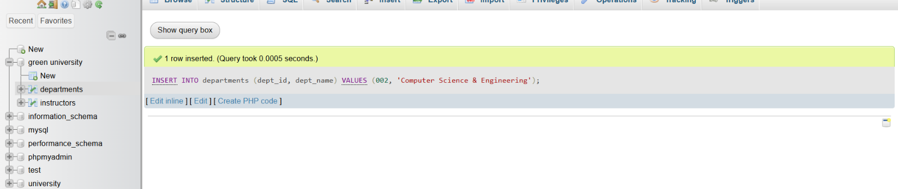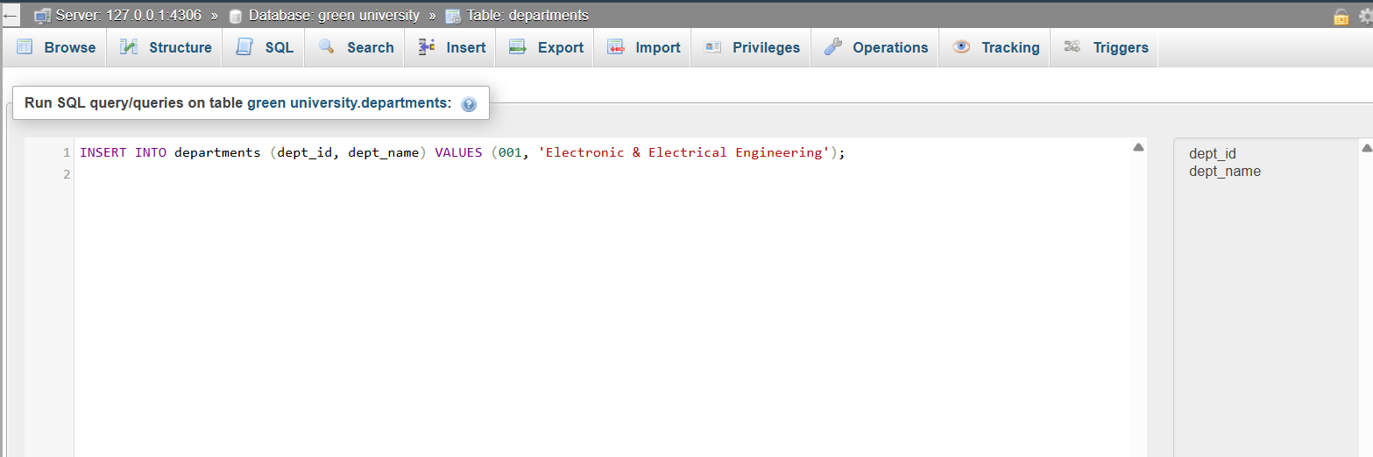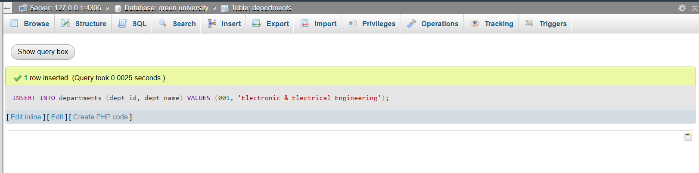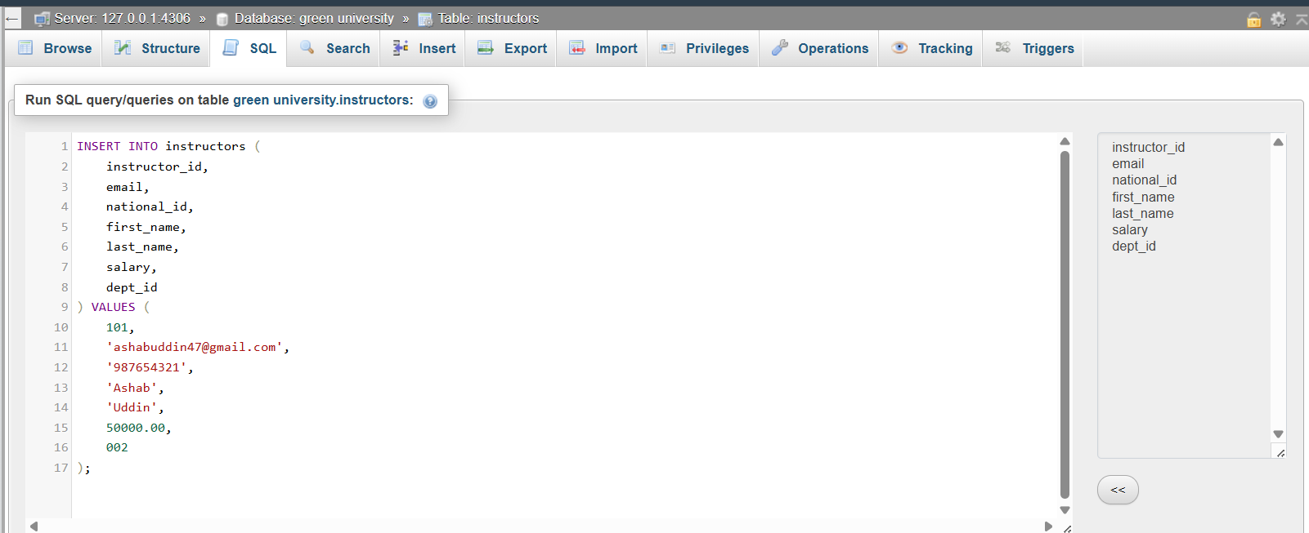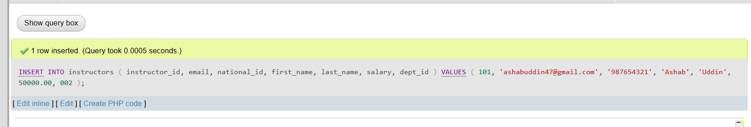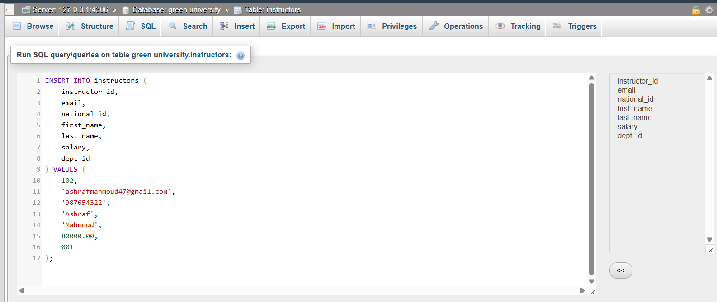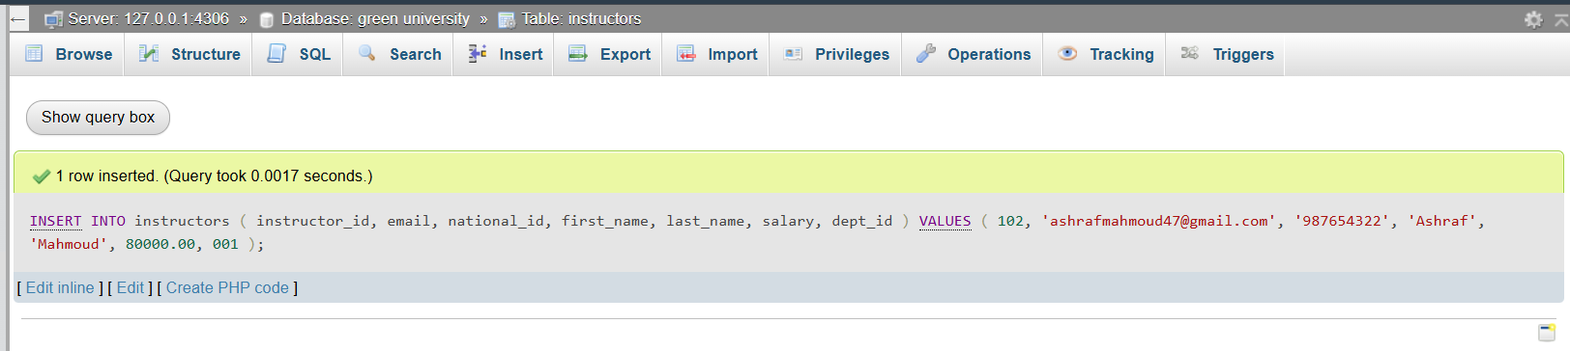

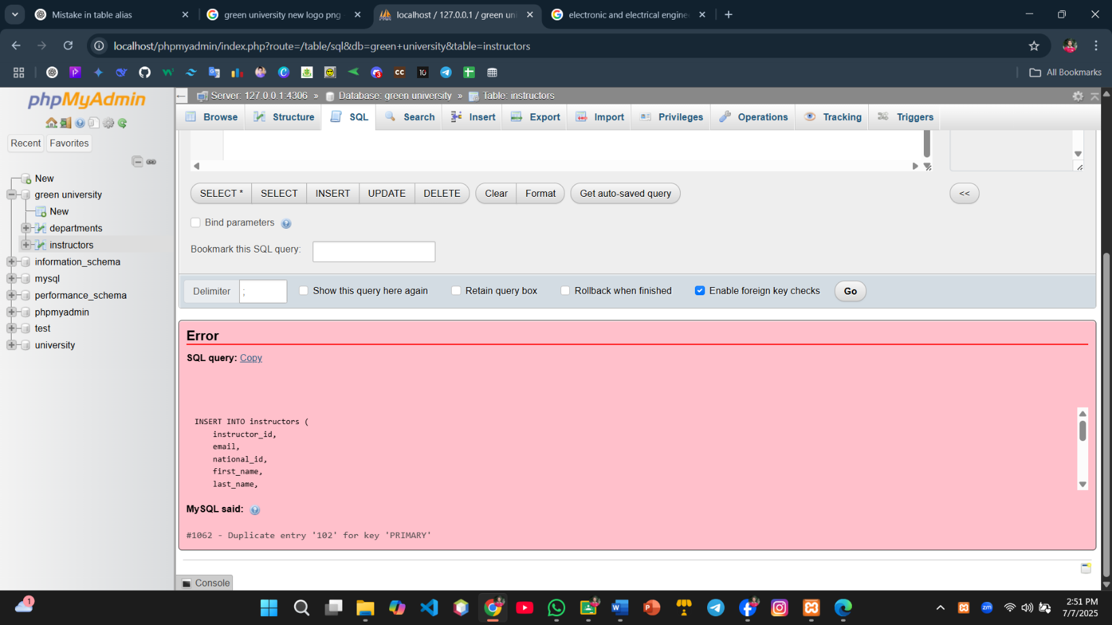

**OUTPUT:**





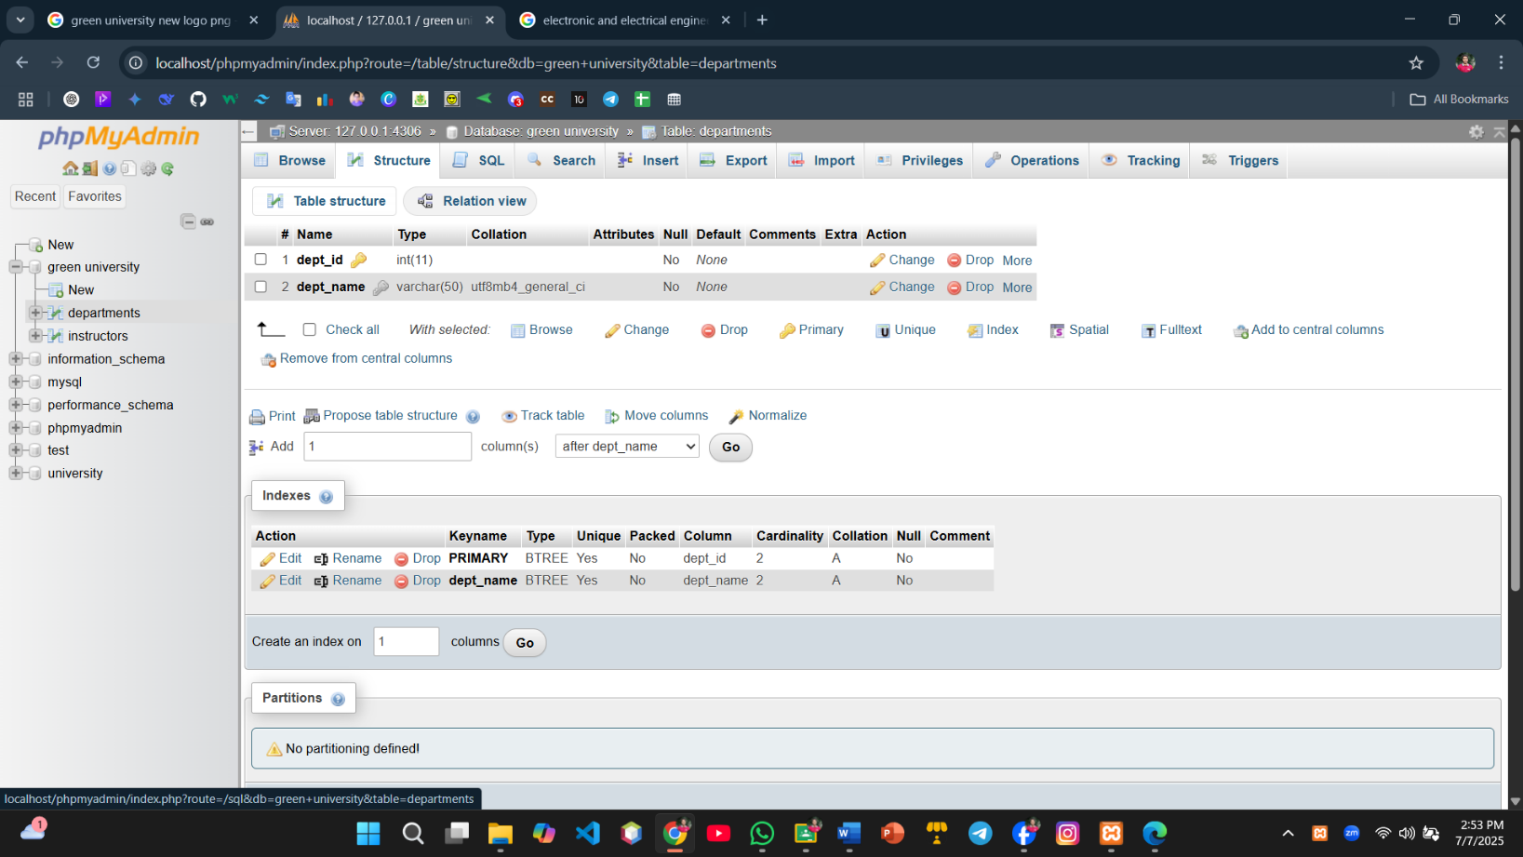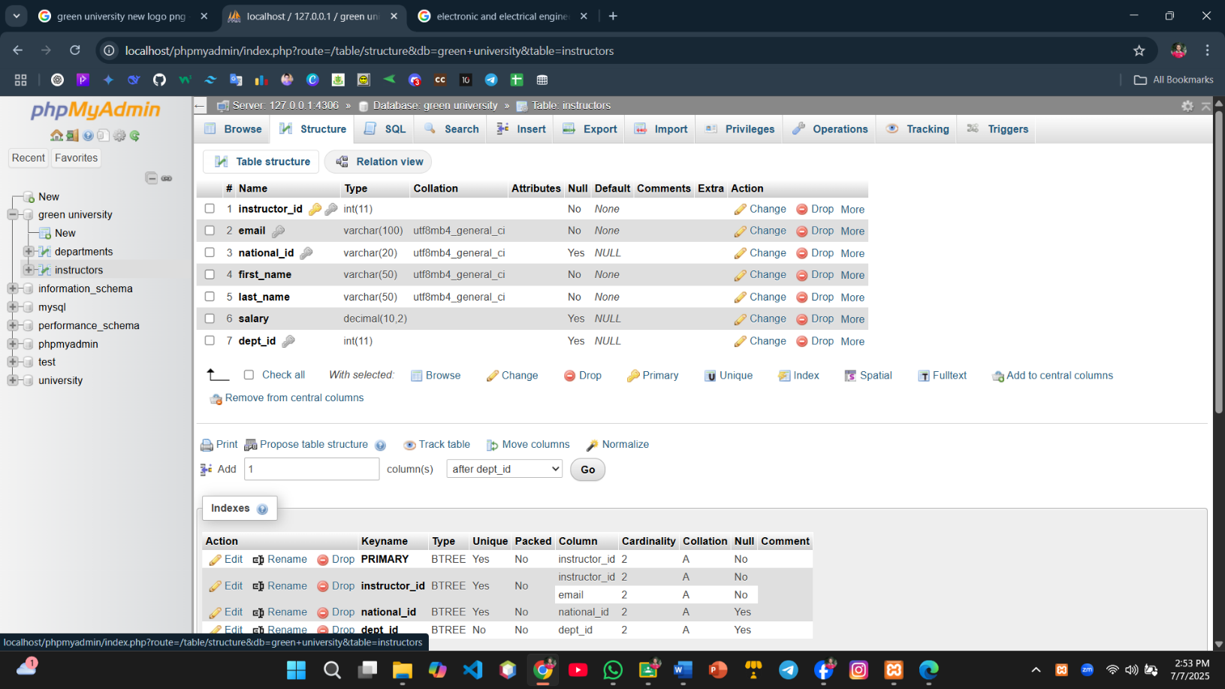

**Discussion:**  
The above SQL implementation demonstrates how integrity constraints ensure data reliability in relational databases. Primary keys uniquely identify each instructor, while unique and not null constraints enforce data consistency. The foreign key constraint maintains referential integrity by linking instructors to valid departments. Check constraints validate that salary values are logical. Successful inserts confirm correct schema design, whereas errors help detect violations, illustrating the importance of constraints in preventing invalid data entry.